Omni directional

Lockable wheels

Maintains reasonable temp for baby

Ergonomic handle

Users should not need to bend over to load and deload baby

Should have storage for baby essentials

Optional foldable

Optional carrier is detectable and used as car seat

Optional rockable

Figure out why babies cry on buses and trains, and figure out a solution

Removable padding for ease of cleaning

Wheels should be replaceable

Suspension for bumps

Rain and sun protection

Adjust for all sizes of children

Optional Have space for more than one occupant

Adjustable heights for different size of people so they don’t hunch over

System to deal with diapers and waste

The project must have acceptable mobility within small spaces such as public transportation.

Research common items that is stored

Users

Women

Men

Kids

Infants

Environment

City

Suburban

Beach

Park

Public transportation

Three wheel design is not ideal b/c when boarding public transportation stroller users prop the strollers on it's back wheels then front wheel to lift the stroller. With 3 wheels it forces users to balance the Stroller laterally when propin n the front wheel

Think about Center of mass on incline and for propin

Toggling w

Swivel wheels

Copper infused fabric

Bamboo fabric

Hollow frame to reduce weight

Should be push able for pregnant moms with large stomachs

Front heavy is better b/c easier to use your weight to push down then lift up

Saw mom cover stroller with blanket to help baby calm down on ttc

Research old person walking aid for inspiration for Swivel wheels

The product must move at the speed at which the user walks with reasonable force which the user produces when walking

The product must fold to fit within an 9 cubic feet space

The product must have locking/latching system to prevent unintentional folding

The product must weight no more than 30lb

The product must hold no more than 100 lbs with no more than 1 infant/ small child

The product must have separate storage compartment

The product must have an UPF rating no less than 40

The product must have a Factor of Safety (FOS) of 2

The product must stand on its own on public transport

The product must secure the passenger …..

The product must be accessible and reliably fold

The product must have child safety features

The product must be resistant to fluids

The product must have a braking system

The product must secure the passenger such that the user must release the passenger

The product must lock in place on public transport

The product must suit user varying from 150 cm - 200 cm

The product must have high visibility at night

The product must allow the user to monitor the passengers

The product must have minimum ventilation to prevent passenger from suffocating and odor build up

The product must

The product must

Push down wheel for lateral movements

The product must traverse through rough terrains

Sound proofing the stroller??

compliant mechanism?

Compliant fifth wheel mechanism

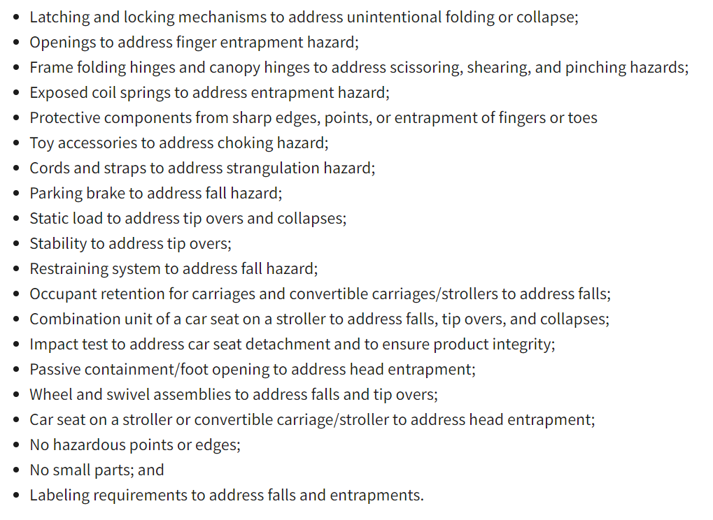

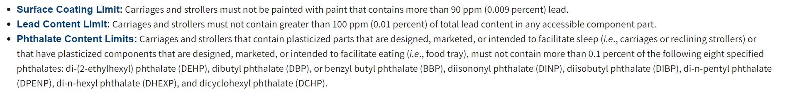

mycelium based packaging

<https://www.youtube.com/watch?v=d-dTXYIiy-M>

Baby name tag

Requirements missing adjustable handle heights

Stickers to label steps on stroller

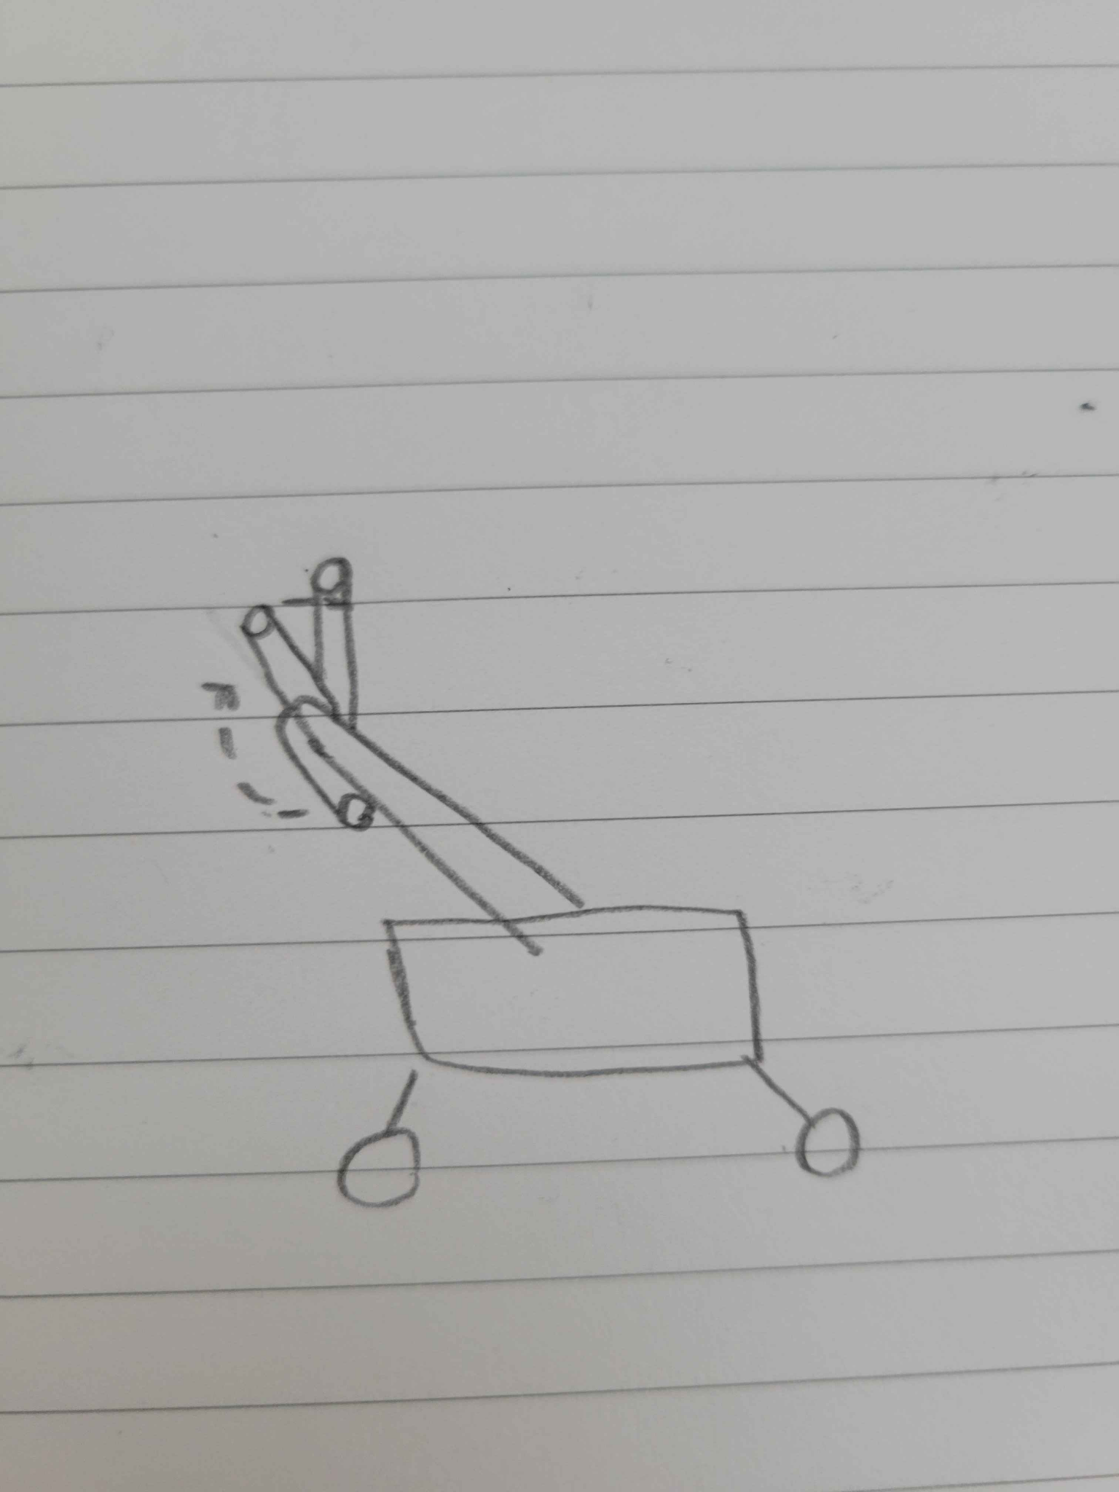

Rotating adjustable handles provide wider range of heights in a smaller form factor

triple wheel for going up stairs